# Methods

## Sample preparation

Samples of the pure culture without material and the pure culture with 0.5 g/L AC were taken in three different times, namely during the initial methane production phase, the middle of the exponential phase and in the end of the exponential phase for each condition (with and without AC, respectively).

Each sample was composed of 4 spectra files, with 2 files for each of the 2 runs: first, all samples where run with 1uL, and the volume for the second run was adjusted by the obtained signal and amount of sample available.

## Bioinformatics analysis

For protein identification, the analysis was based on MOSCA’s workflow using compomics tools.

### Database

The *M. formicicum* strain used in these assays was DSM 1535 and the corresponding proteome was used as database, together with cRAP database for identification of contaminants and trypsin. The proteome of this strain possesses 2392 proteins (<https://www.uniprot.org/proteomes/UP000032423>), and the full database contained 2509 sequences. Decoy database was built from the cRAP + *M. formicicum* database.

### Peak picking

Raw files (.wiff and .wiff.scan) were converted to Mascot Generic Format (mgf) using MSConvert for performing protein identification with SearchGUI.

### Protein identification

Protein identification was performed with SearchGUI (3.3.16) using custom parameters: precursor ion mass tolerance = 10 ppm; fragment tolerance = 0.02 Da; digestion: Enzyme, Trypsin, Specific; fixed modifications: Carbamidomethylation of cytosine; variable modifications: oxidation of methionine; maximum missed cleavages: 2; search engines: X!Tandem, Myri-match, MS-GF+.

### Report generation

Peptide-Shaker (1.16.41) was used for browsing results and generating reports – TSV tables of protein identification.

### Protein quantification

Spectra count was performed on the data available at the protein report of Peptide-Shaker.

# Results

## General results

Table 1 - general metrics of protein identification. Quantification of spectra detected in Mass-Spectrometry (MS/MS), Peptide-to-Spectrum Matchings (PSMs), different proteins and different Cluster of Orthologous Groups (COGs) in the samples detected in the samples.

|  |  |  |  |  |  |  |
| --- | --- | --- | --- | --- | --- | --- |
|  | *M. formicicum* (control assay) | | | *M. formicicum* with 0.5 g/L AC | | |
|  | Initial of methane production (MP) | Exponential phase | End of exponential phase | Initial of MP | Exponential phase | End of exponential phase |
| # of spectra | 89092 | 92588 | 83746 | 83681 | 59273 | 86619 |
| # of PSMs | 14773 | 11064 | 19279 | 6370 | 11807 | 15061 |
| # of proteins | 418 | 340 | 542 | 219 | 379 | 434 |
| # of COGs | 368 | 301 | 467 | 196 | 335 | 373 |

## Functional analysis

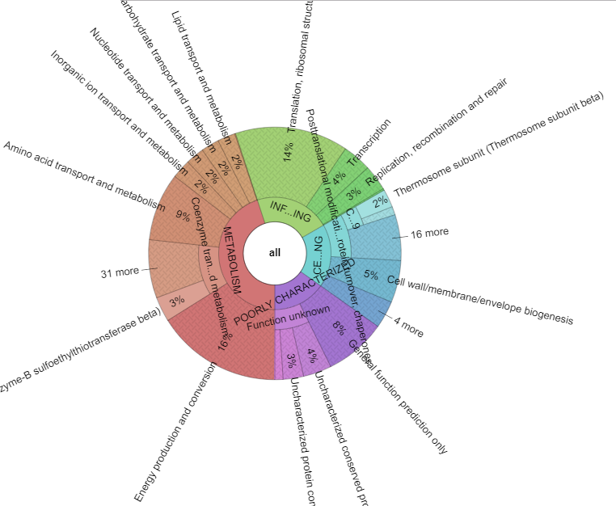

Figure 1 - COG composition of sample 1 (Control initial of MP)

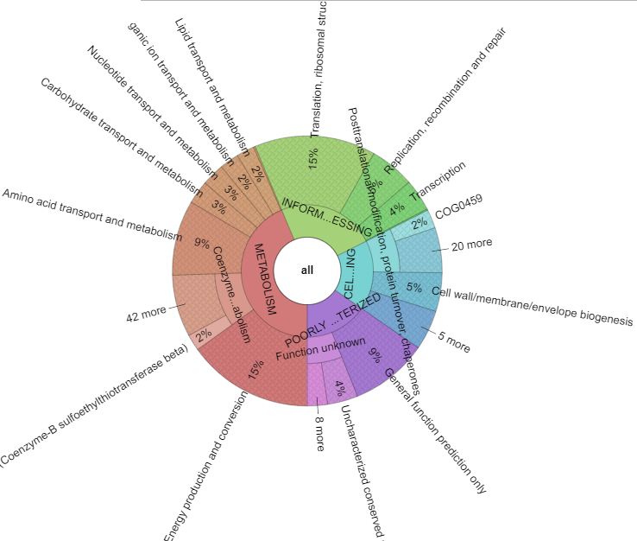

Figure 2 - COG composition of sample 2 (control exponential phase)

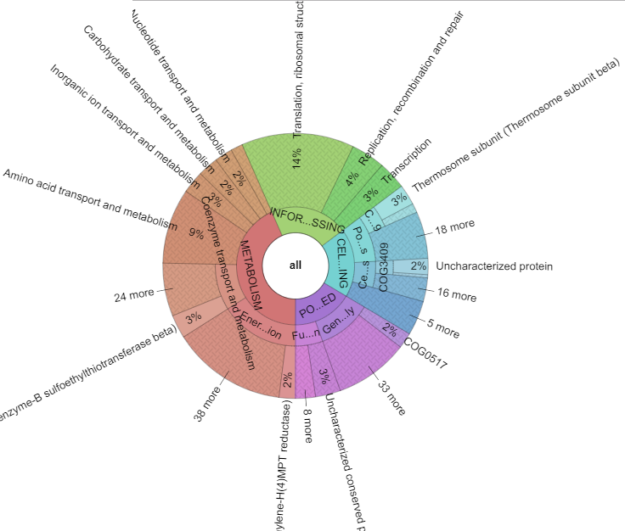

Figure 3 - COG composition of sample 3 (Control end of exponential phase)

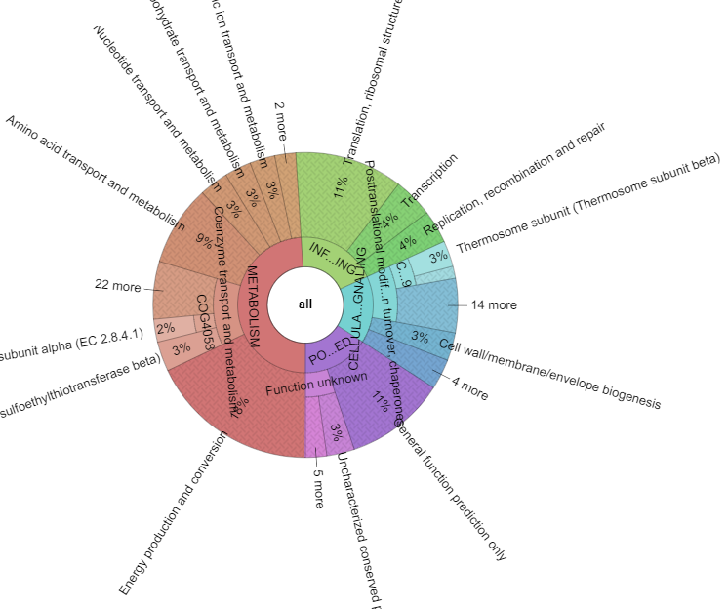

Figure 4 - COG composition of sample 4 (AC initial of MP)

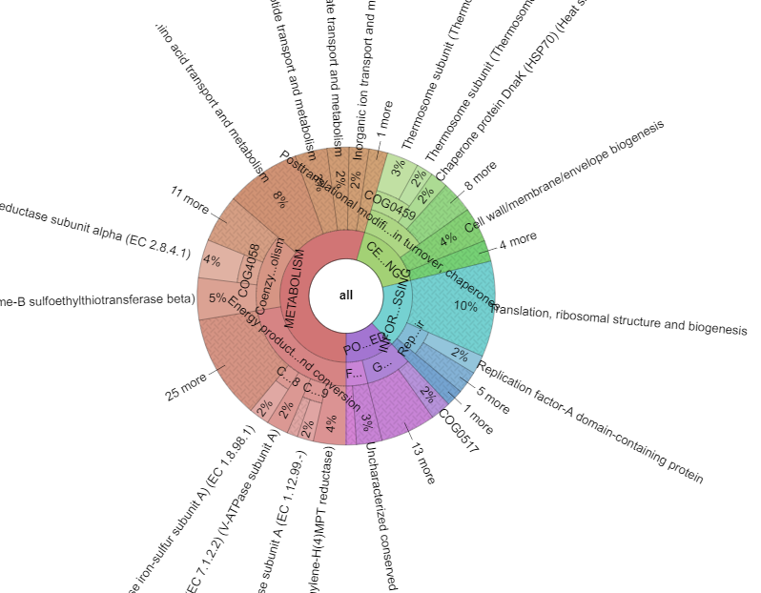

Figure 5 - COG composition of sample 5 (AC exponential phase)

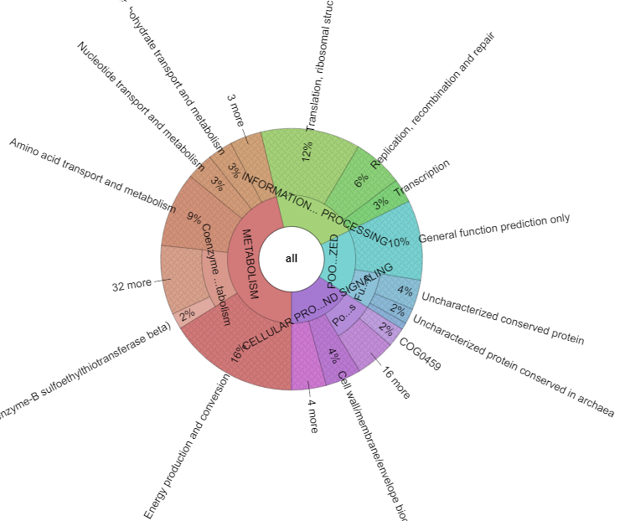

Figure 6 - COG composition of sample 6 (AC end of exponential phase)